Design and Development of Event Management System

**A**

**MAJOR PROJECT-II REPORT**

Submitted in partial fulfilment of the requirements

for the degree of

**BACHELOR OF TECHNOLOGY**

**in**

**COMPUTER SCIENCE & ENGINEERING**

By

**GROUP NO. 13**

|  |  |  |  |
| --- | --- | --- | --- |
| **Ankit Vishwakarma** | **Divyanshi Pandey** | **Geetanjali Kushwaha** | **Harsh Khare** |
| 0187CS191028 | 0187CS191049 | 0187CS191054 | 0187CS191060 |

Under the guidance of

**Prof. Jai Mungi**

(Professor)

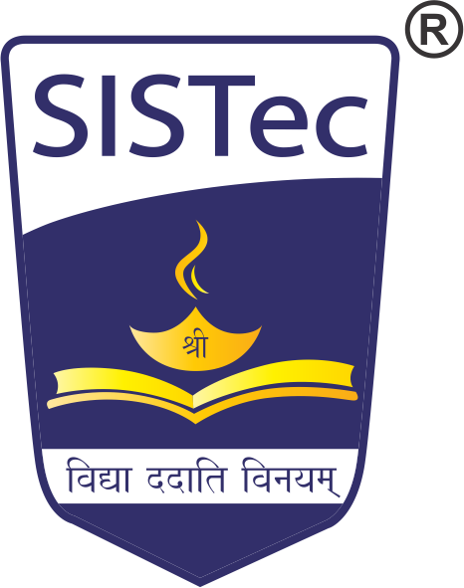

**June-2023**

**Department of Computer Science & Engineering**

**Sagar Institute of Science & Technology (SISTec)**

**Bhopal (M.P.)**

**Approved by AICTE, New Delhi & Govt. of M.P.**

**Affiliated to Rajiv Gandhi Proudyogiki Vishwavidyalaya, Bhopal (M.P.)**